**Assignment 1**

**Due, Sunday, May 28, 2017 for maximum 100**

**Monday, May 29, 2017 for maximum 90**

**Tuesday, May 30, 2017 for maximum 80**

**Wednesday, May 31, 2017 for maximum 70**

**Assignment Scope**

1. Netbeans IDE familiarity
2. Create a Java Swing project
3. Create a package
4. Create a class
5. Create an interface
6. Write simple Java source code
   1. Use a Java API library class and its *static method to write output to the output console
      1. Call System.out.println();
      2. Pass as an argument the explicit text “Welcome to Boggle!”, to include the double quotes
   2. Use a Java API library class and its *static method to display a UI message to the user that requires using an import statement
      1. Call JOptionPane.showMessageDialog(arg1, arg2); using the method signature that uses only two parameters (there are three versions of the method)
      2. Pass as an arguments
         1. The value null for the first argument; this argument is referencing which UI component is the parent class, in this case there isn’t one for now
         2. Explicit text “Let’s Play Boggle!” as the second argument, to include the double quotes
7. Add an external file to a Java project
   1. BoggleData.txt
   2. Dictionary.txt
8. Compile and run a project
9. Compress a project and submit to Webcourses
10. Decompress compressed project and verify it is a Netbeans project

**References**

1. Netbeans.docx
2. Setting up a project in Netbeans.docx
3. Netbeans right click menu help.docx

**Deliverables**

To complete this assignment you must submit your **compressed Netbeans project** to Webcourses.

**Note**

* A static method is a method in a class that can be called directly versus having to instantiate an instance of the class first.

**Tasks and Rubric**

For points assessment per task please reference grading rubric on Webcourses

|  |  |
| --- | --- |
| Activity | |
| Boggle project | Create a new Java Application project named Boggle  allowing Netbeans IDE to create the main class called Boggle |
| Boggle class | Method main() should:   1. Call static method System.out.println() and result in displaying “Welcome to Boggle!” to the IDE output window 2. Call static method JOptionPane.showMessageDialog(arg1, arg2) and result in displaying a message dialog displaying “Let’s Play Boggle!” |
| core package | Create package **core** |
|  | Create class **Board.java** |
|  | Create class **Die.java** |
|  | Create interface **IBoard.java** |
|  | Create interface **IDie.java** |
| inputOutput package | Create package **inputOutput** |
|  | Create class **ReadDataFile.java** |
| data package | Create package **data** |
| Data File BoggleData.txt | Store the downloaded data file in the **data** package directory on the hard drive |
| Data File Dictionary.txt | Store the downloaded data file in the **data** package directory on the hard drive |
| userInterface package | Create package **userInterface** |
|  | Create class **BoggleUi.java** |
| Boggle application |  |
| Test Case 1 | Test Case 1 passes |
| Test Case 2 | Test Case 2 passes |
| Test Case 3 | Test Case 3 passes |
|  | Source compiles with no errors |
|  | Source runs with no errors |
|  | Source includes comments |

**Perform the following test cases**

|  |  |  |
| --- | --- | --- |
| Test Cases | | |
|  | **Action** | **Expected outcome** |
| Test Case 1 | **Project view** | Completed project view should look like figure 1 |
| Test case 2 | **Run application** | Netbeans IDE Output window should look like figure 2 |
| Test case 3 | **Run application** | JOptionPane message dialog should display and look like figure 3 |

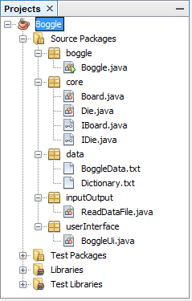

Figure 1 Project View

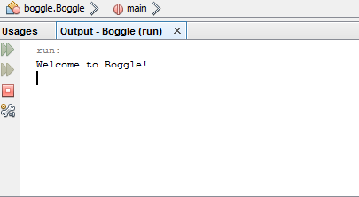

Figure 2 Output window in Netbeans IDE displays System.out.println message

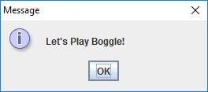

Figure 3 JOptionPane message dialog displays